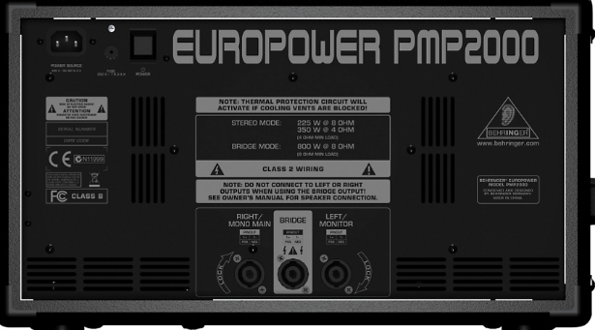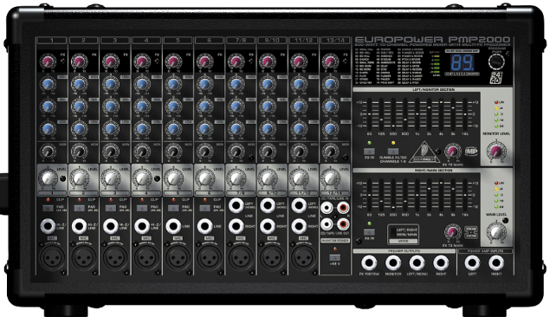**主喇叭(pa)擴大機**

橘 6.3對speakon 藍 6.3對6.3

黃 cannon 對cannon

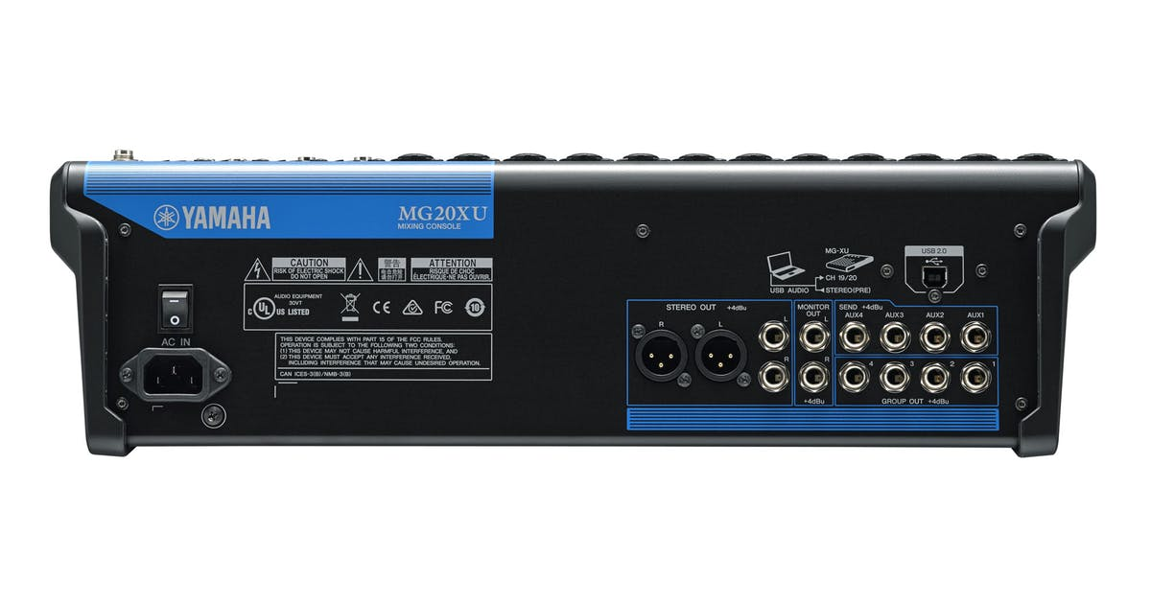ãbehringerãçåçæå°çµæãbehringerãçåçæå°çµæãbehringerãçåçæå°çµæãbehringerãçåçæå°çµæãbehringerãçåçæå°çµæãbehringerãçåçæå°çµæ